**Building a face detecting app on AWS**

* AWS :
  + - aws login screen with username :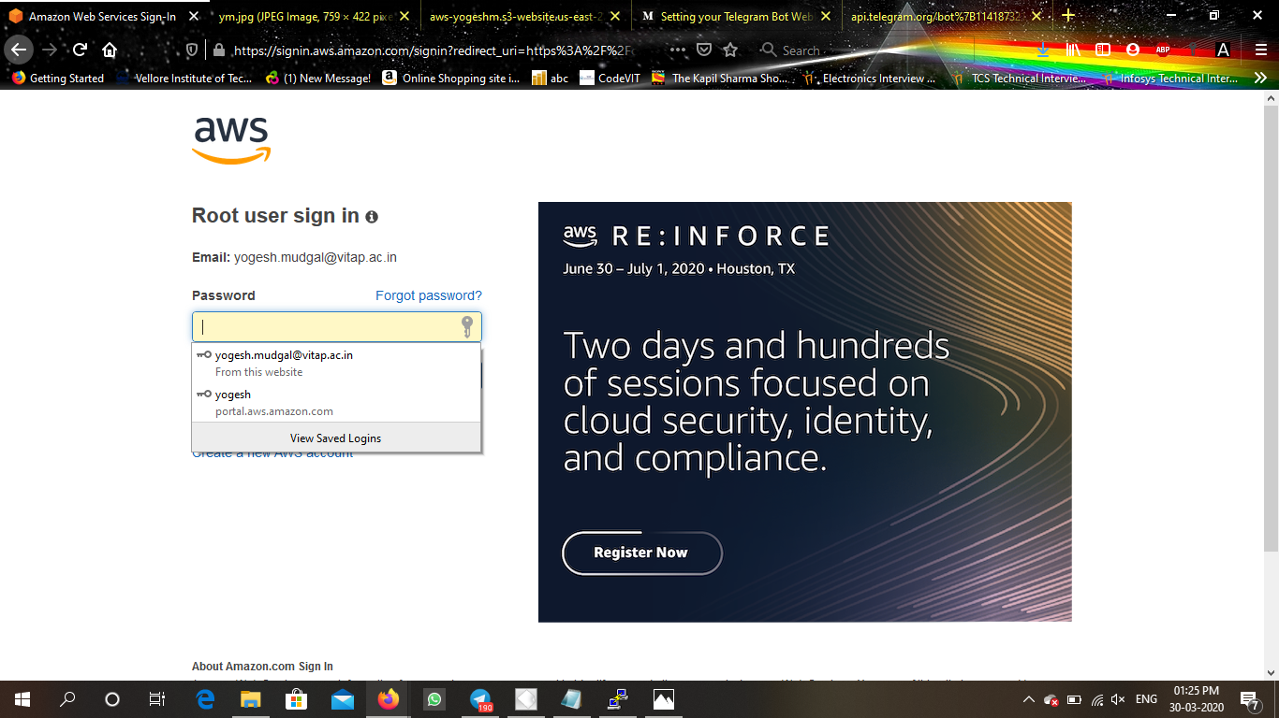
    - EC2 Dashboard: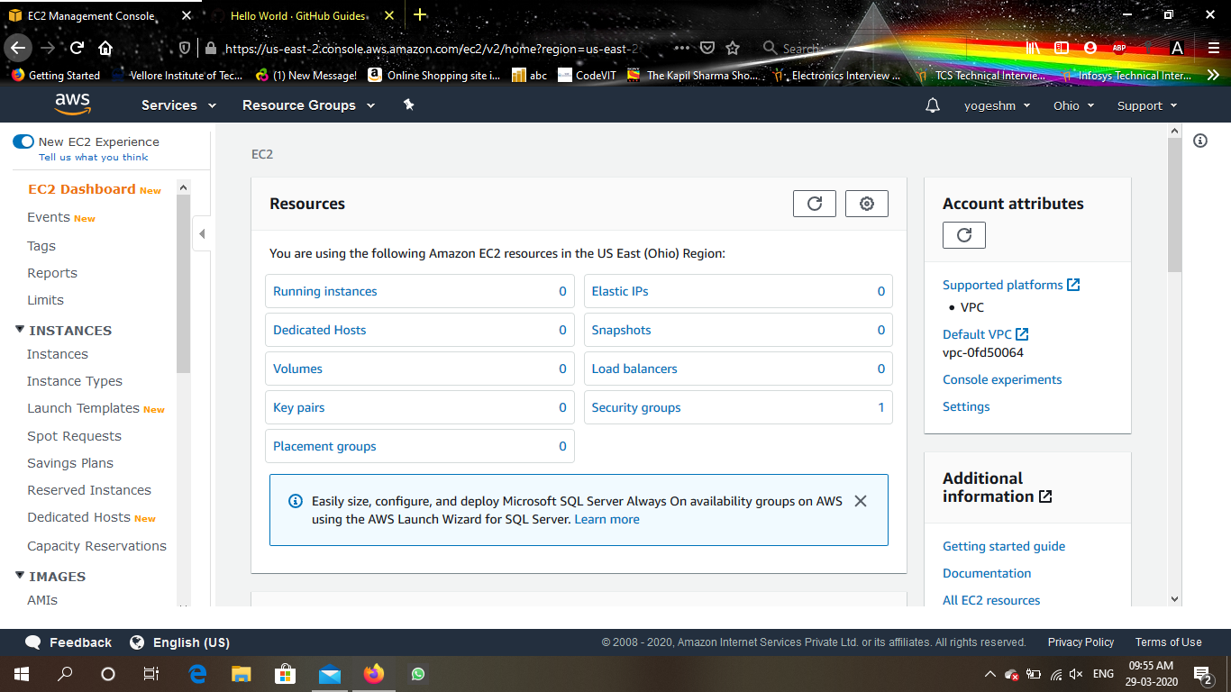
    - S3 Dashboard: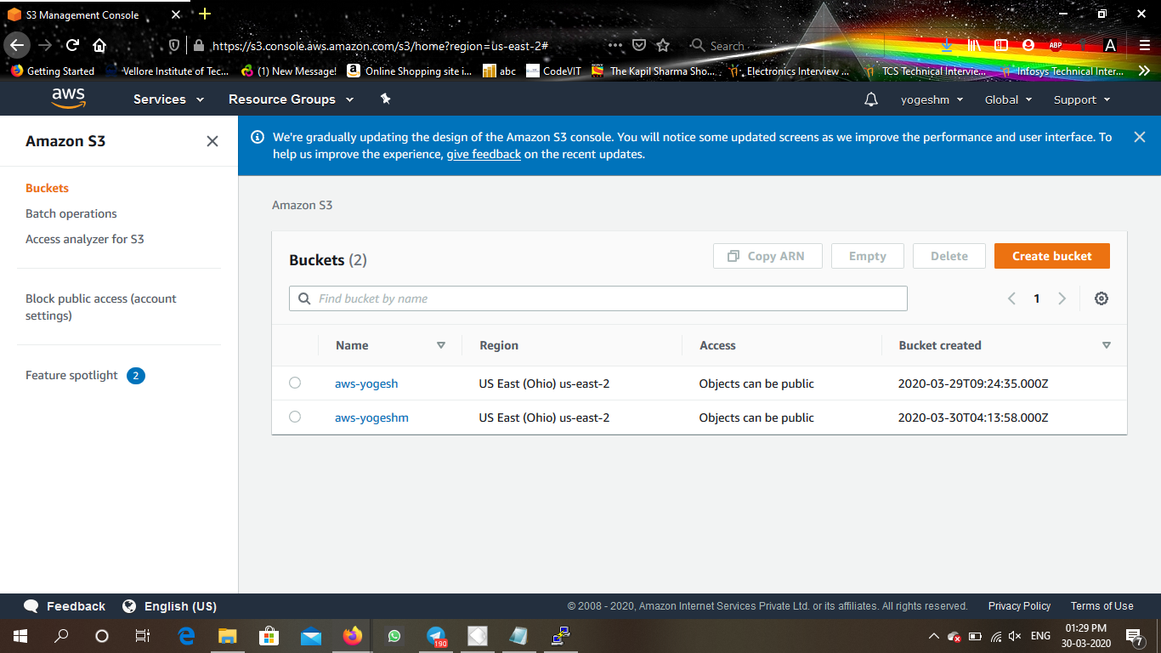
    - Rekognition Dashboard: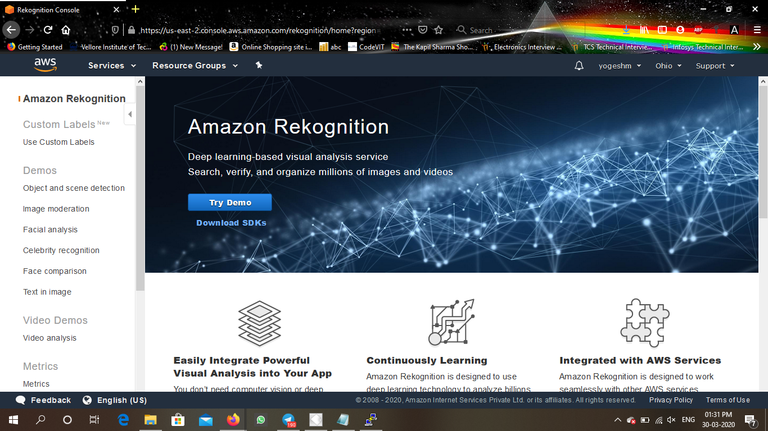
* EC2 :
* Choosing an AMI: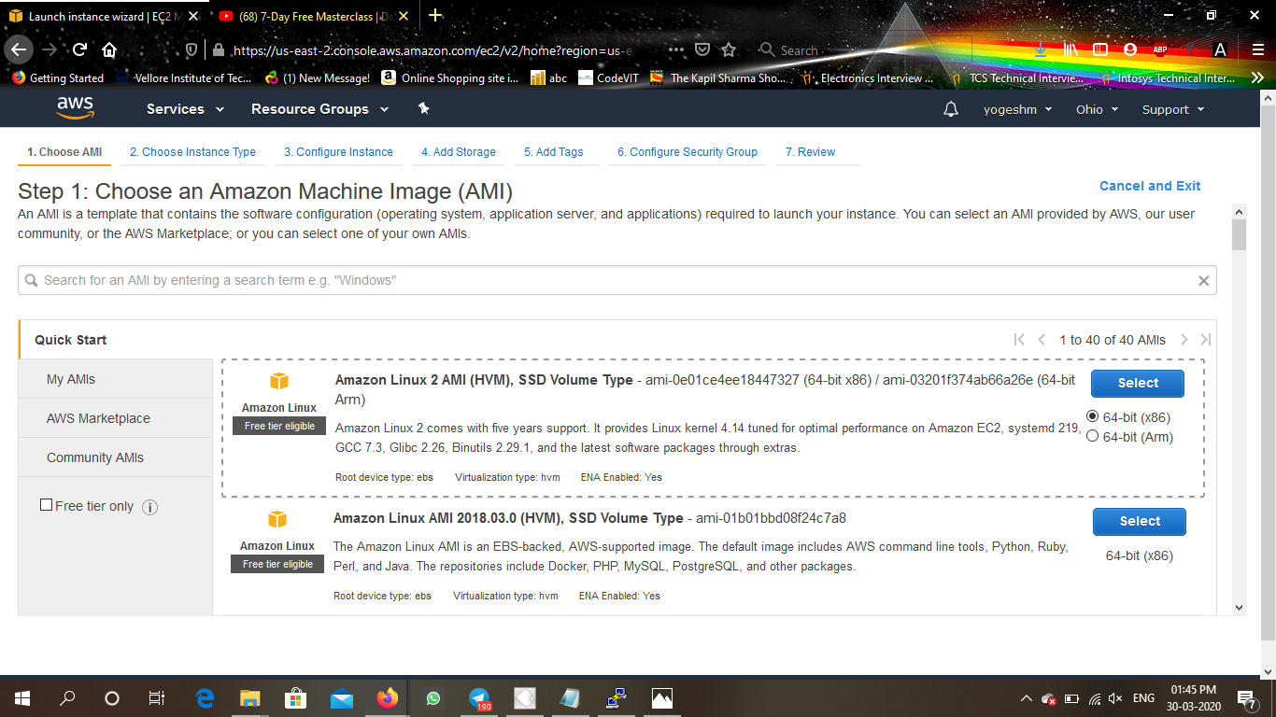
* Choosing an instance type: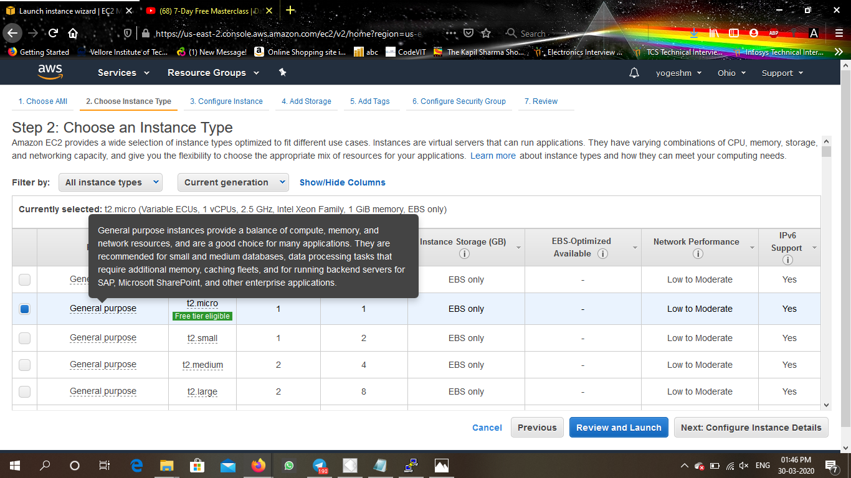
* Adding Storage: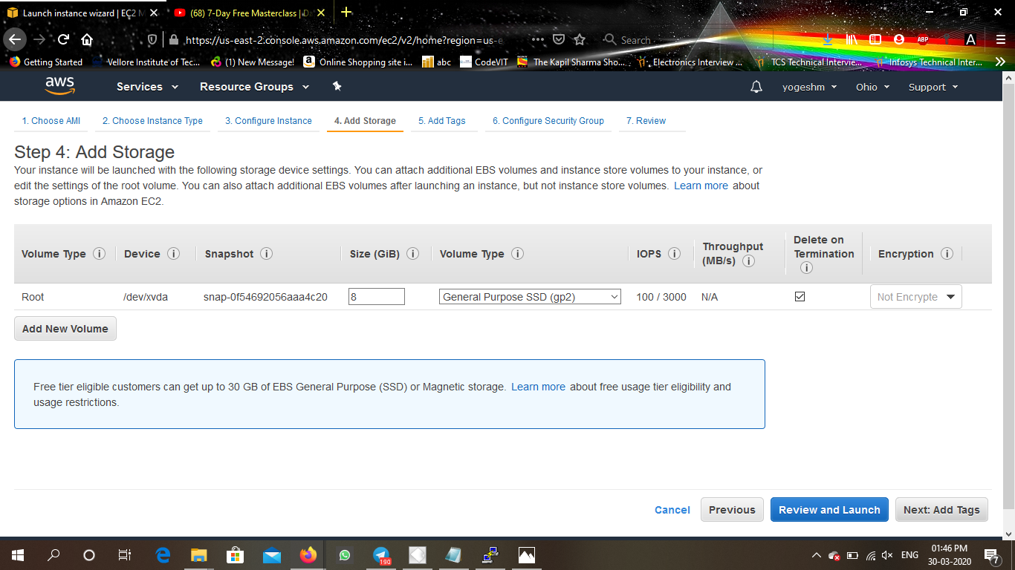
* Configuring security group: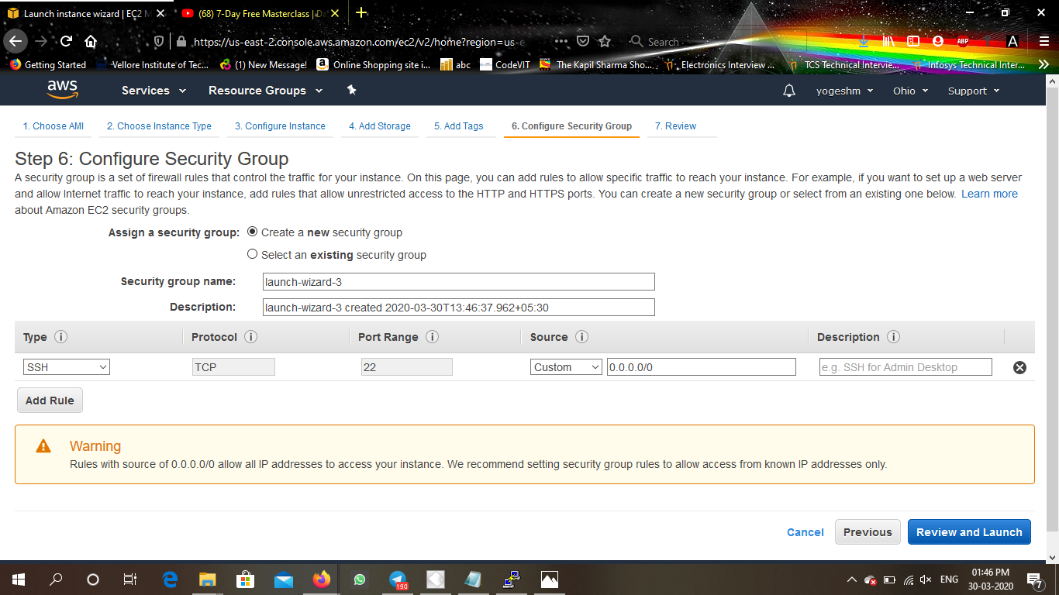
* Key Pair Download: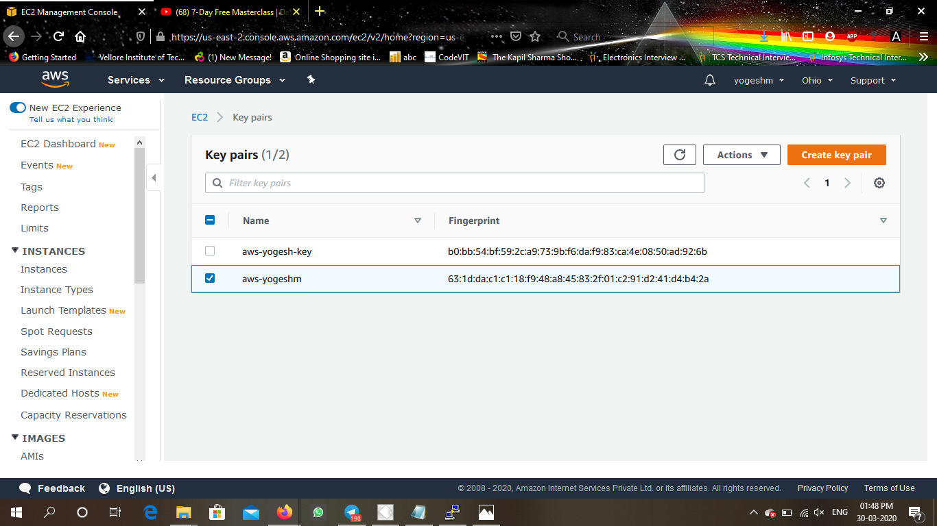
* PuTTYgen conversion from pem to ppk: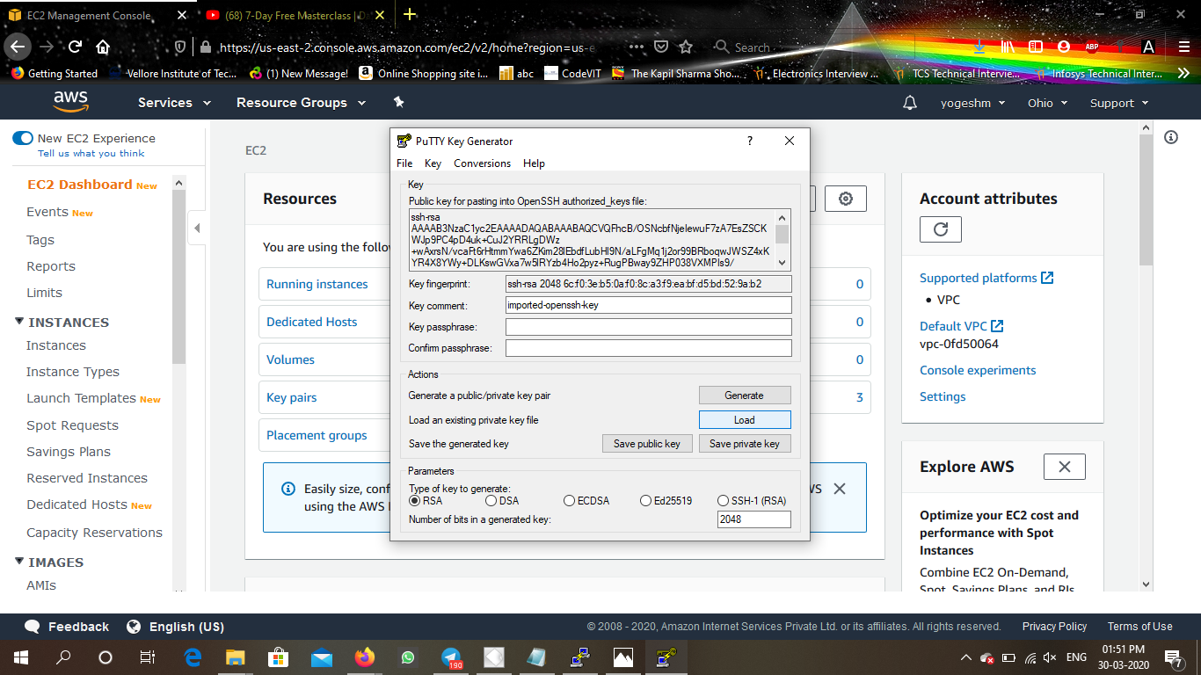
* Logged in EC2 black screen: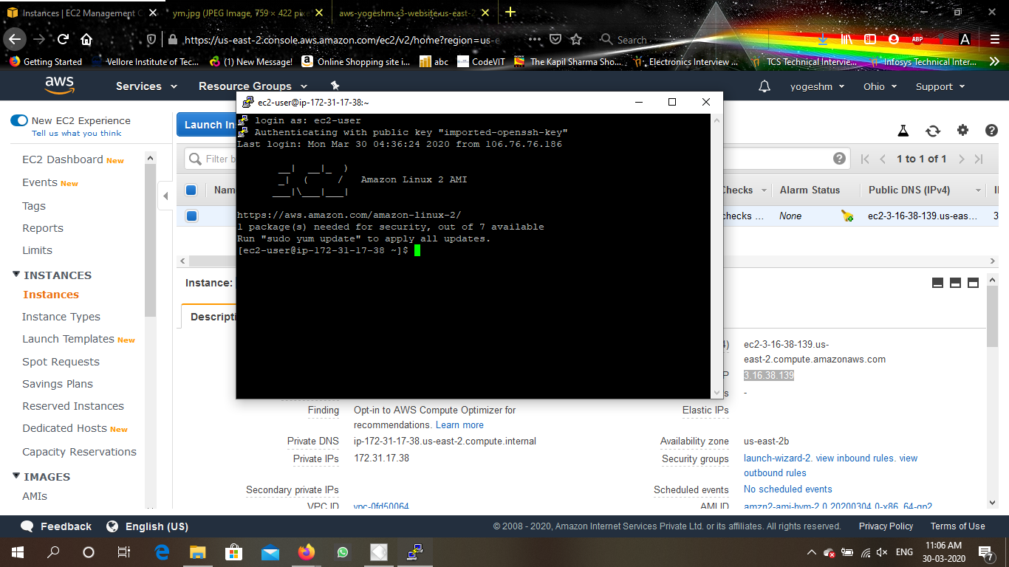
* S3:
  + - Creating a bucket: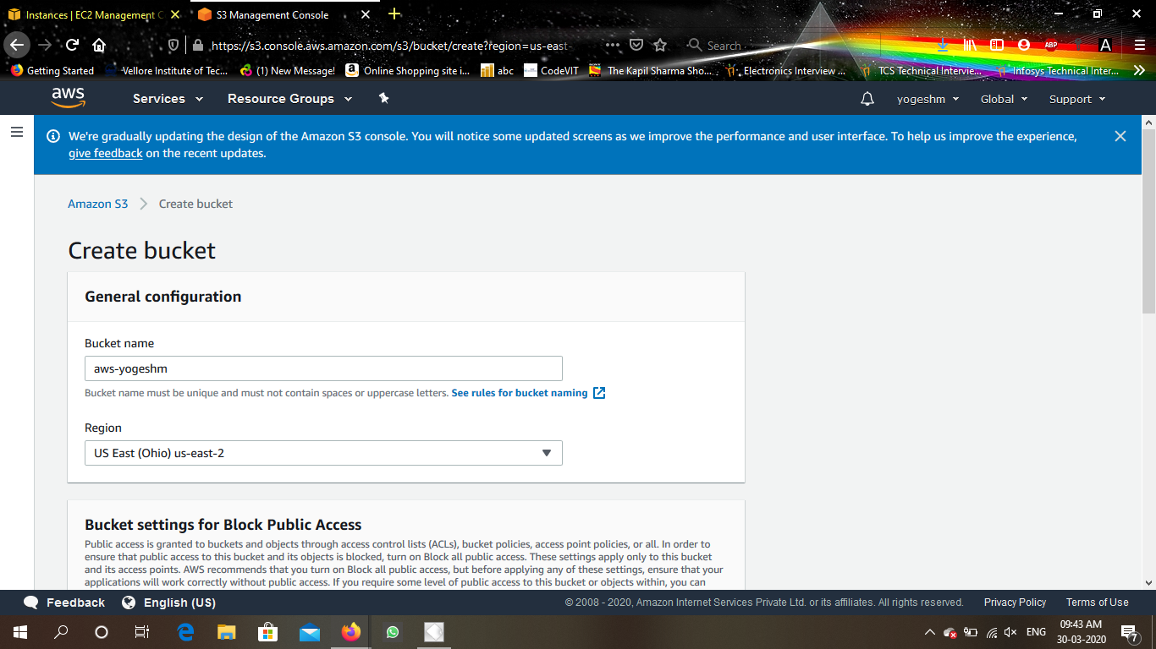
    - uploading an object: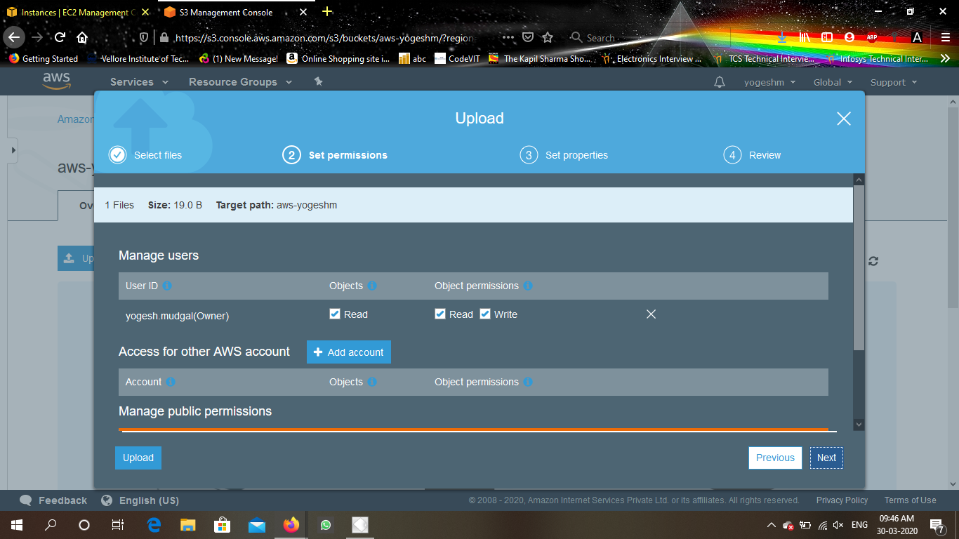
    - Enabling Static Website: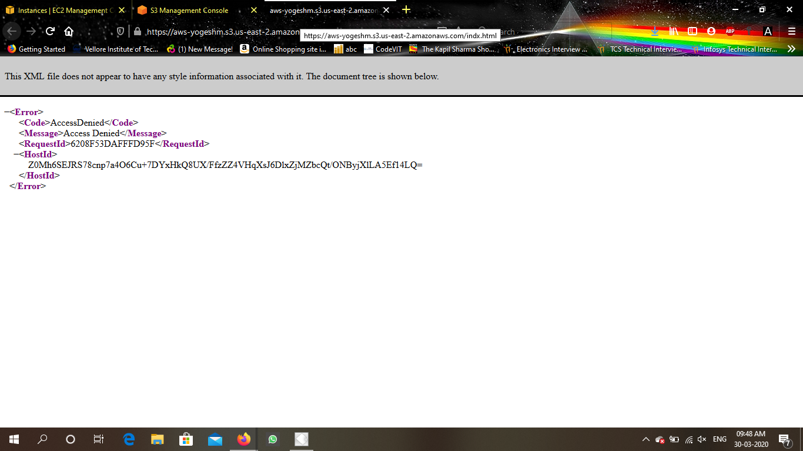
    - Making tje object Public: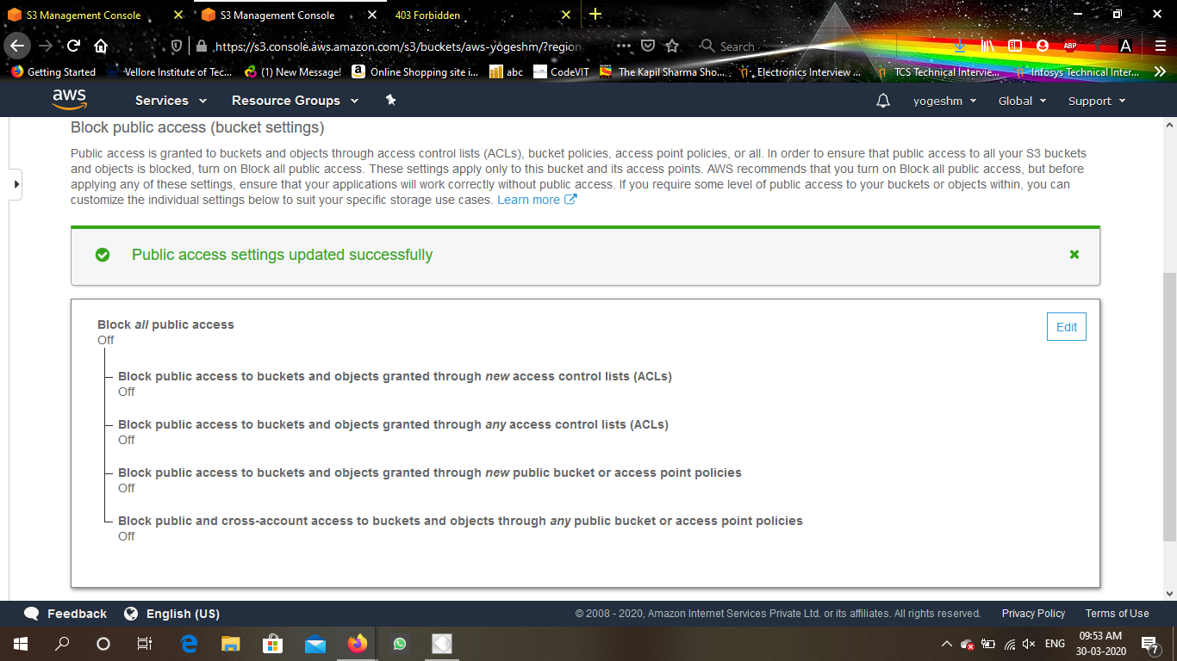
    - Checking the S3 link on the browser:
* Rekognition:
* Face Detect: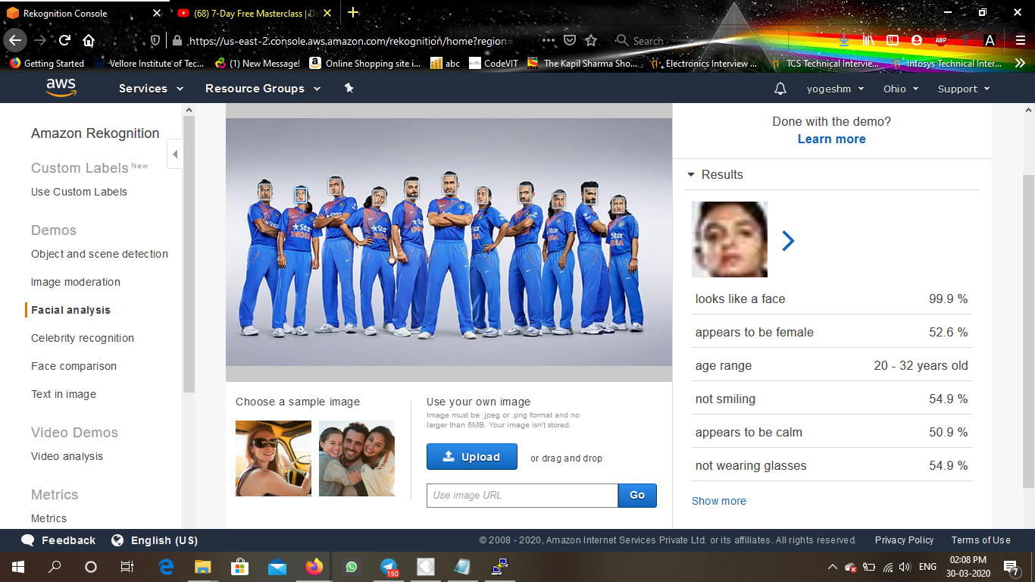
* Face Compare: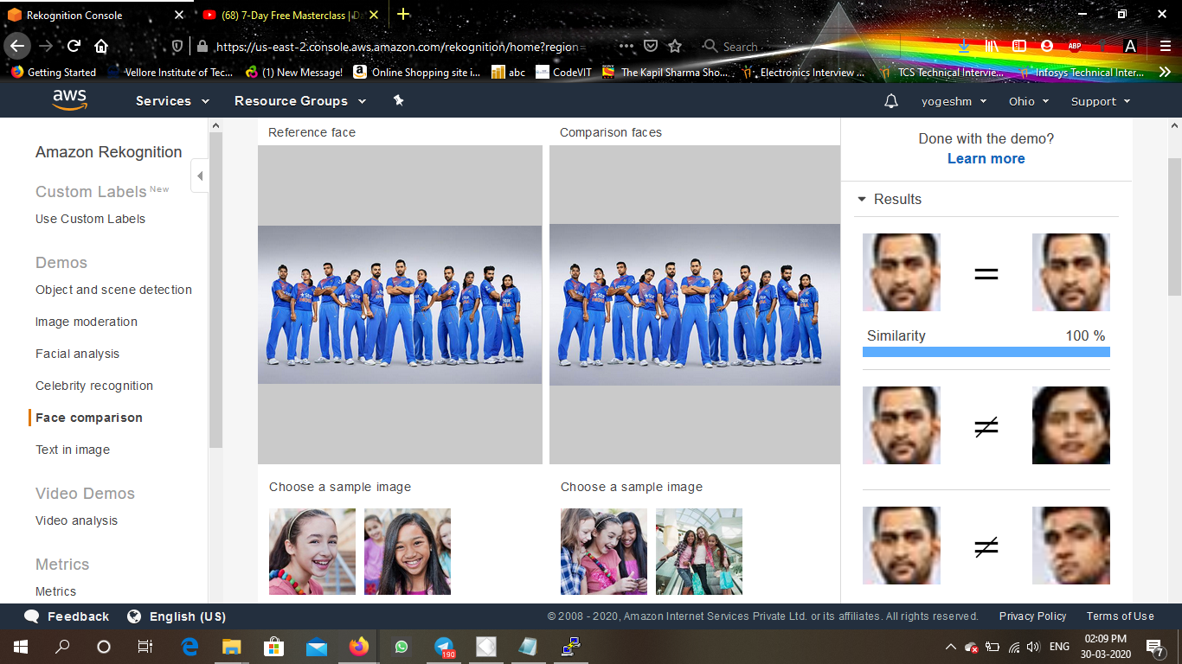
* Celebrity Recognition: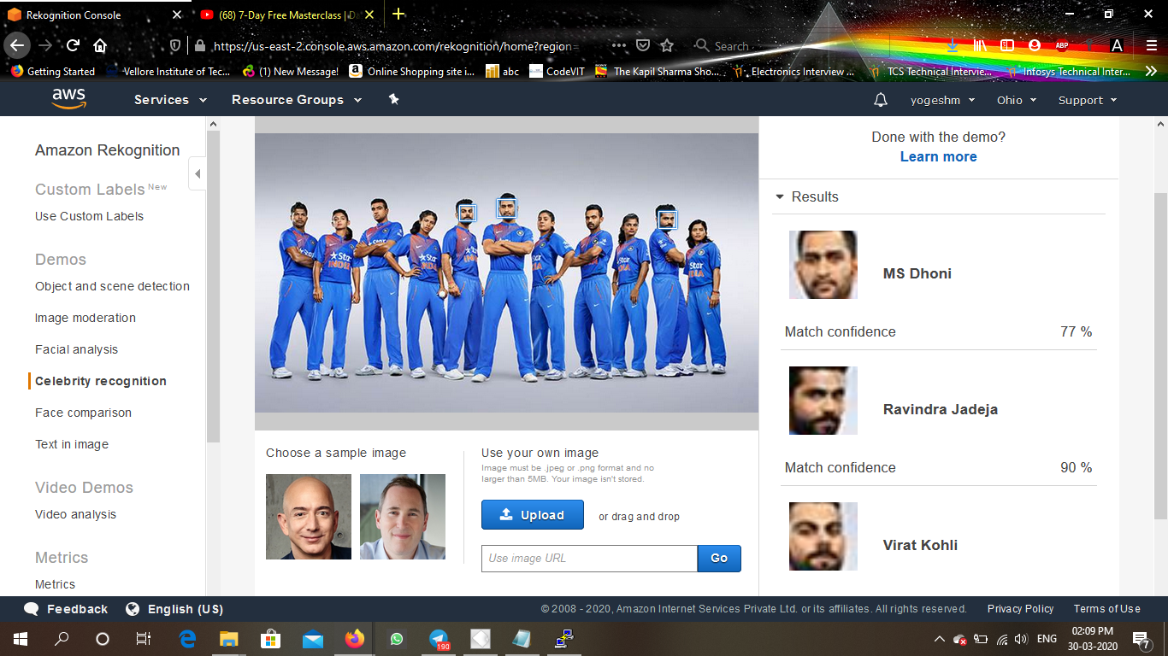
* Text in image: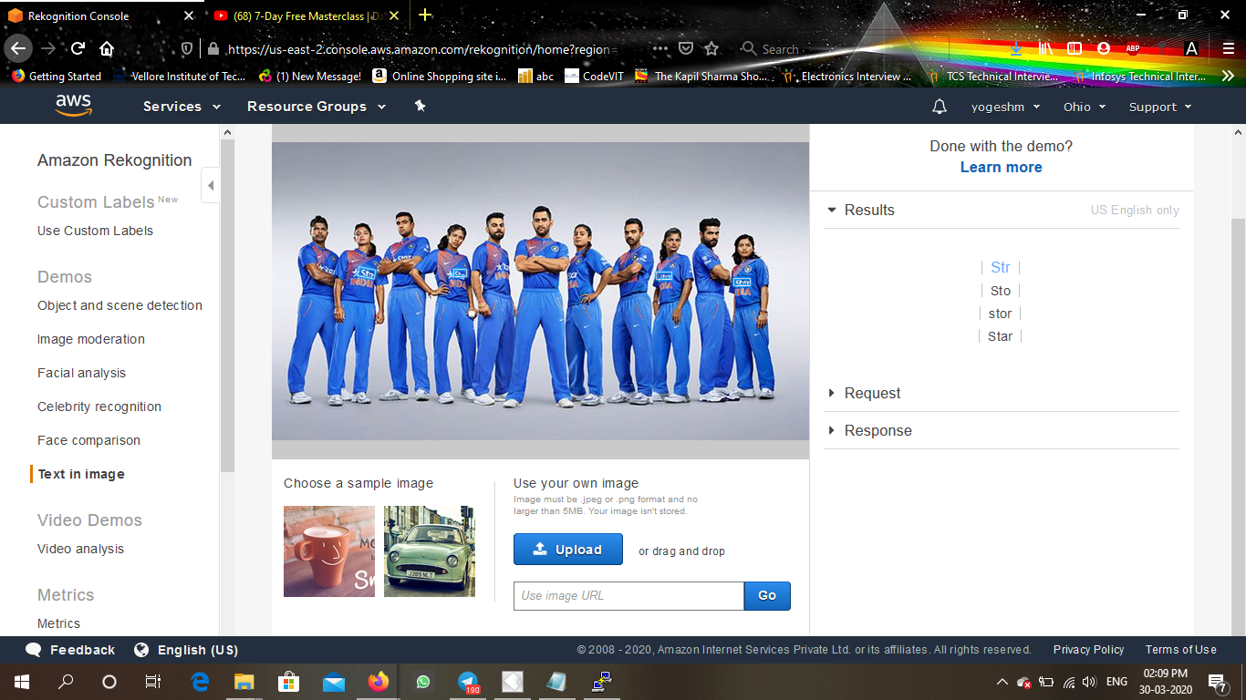
* EC2 &S3:
  + - Installing aws-sdk: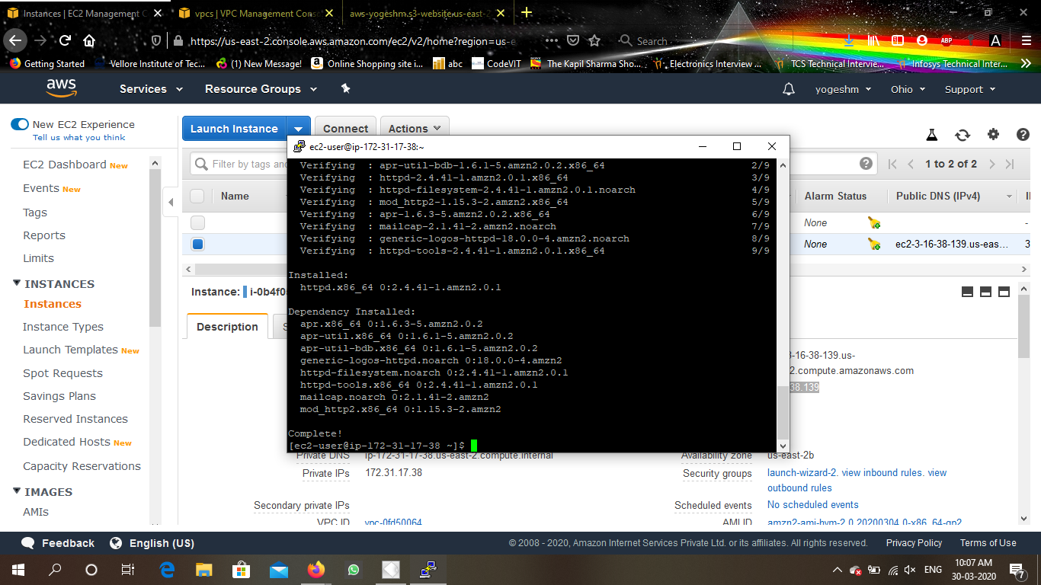
    - Installing php: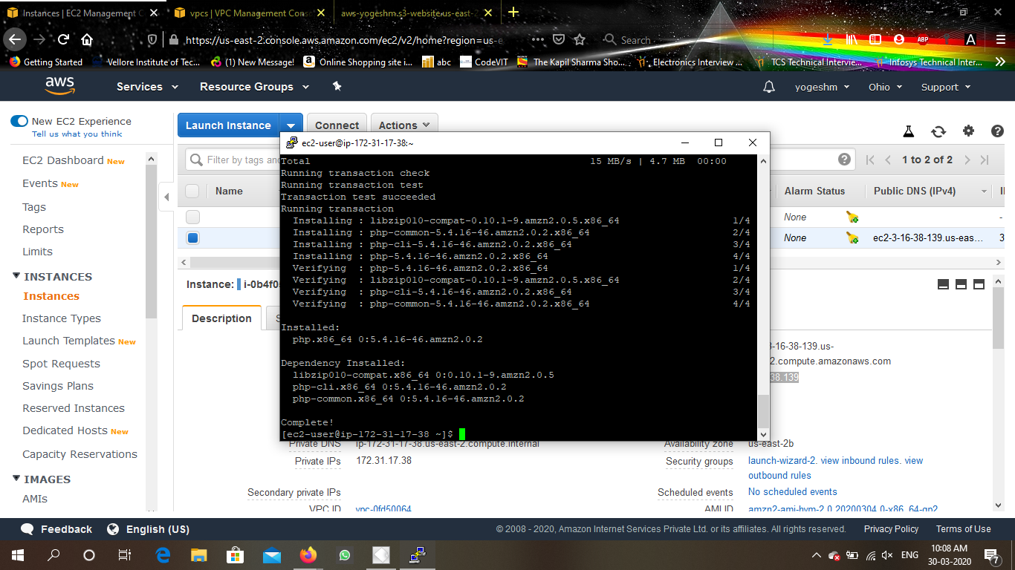
    - index.php file code: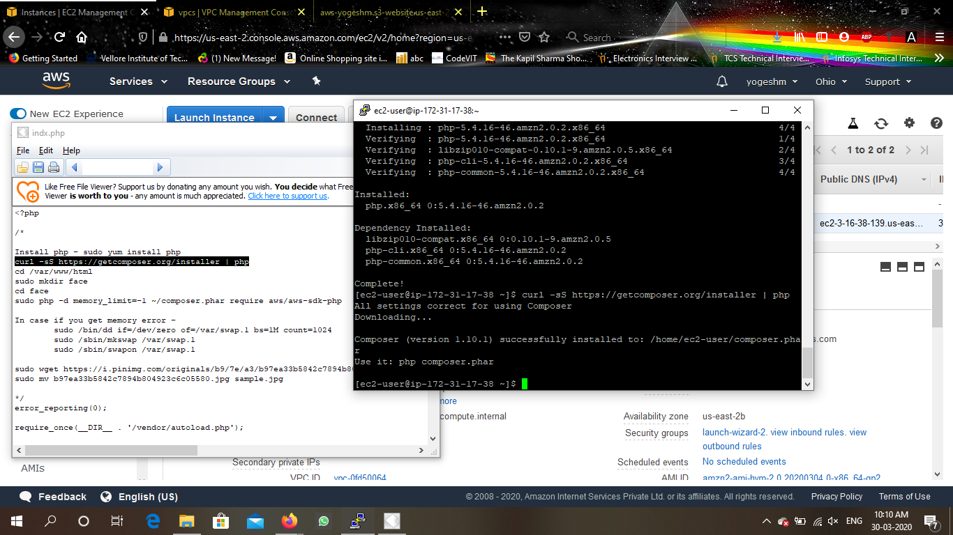
    - Upload success screenshot: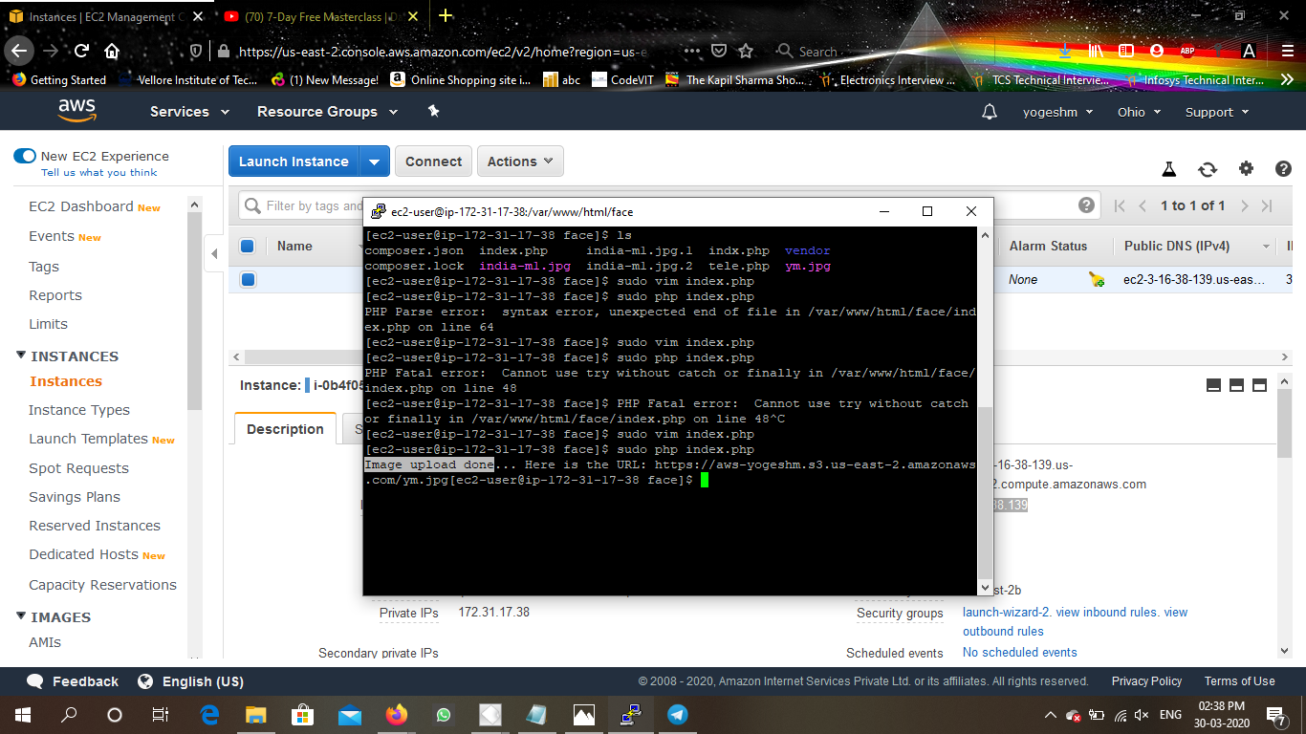
* EC2&Rekognition :
  + - * Face Detect success screenshot: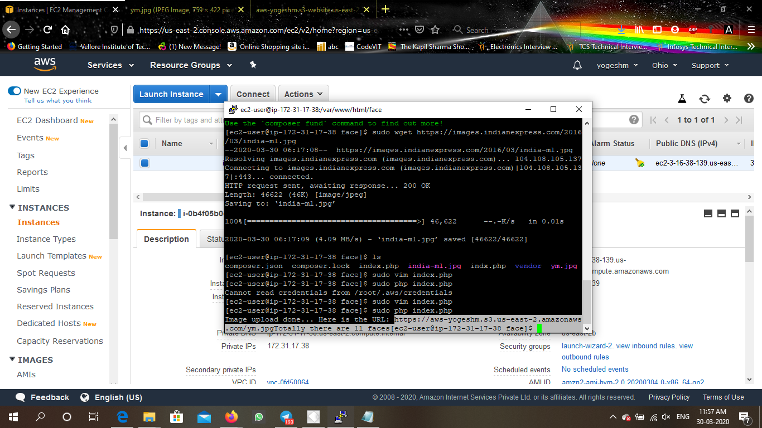

Made by:

YOGESH MUDGAL

yogesh.mudgal@vitap.ac.in

THANK YOU